Tutorial and Building Process
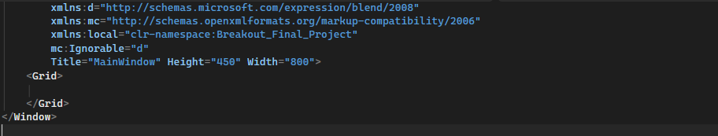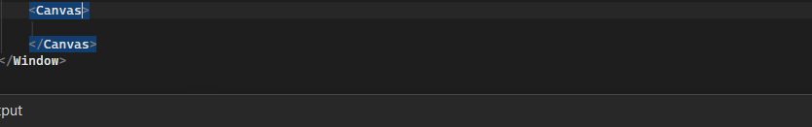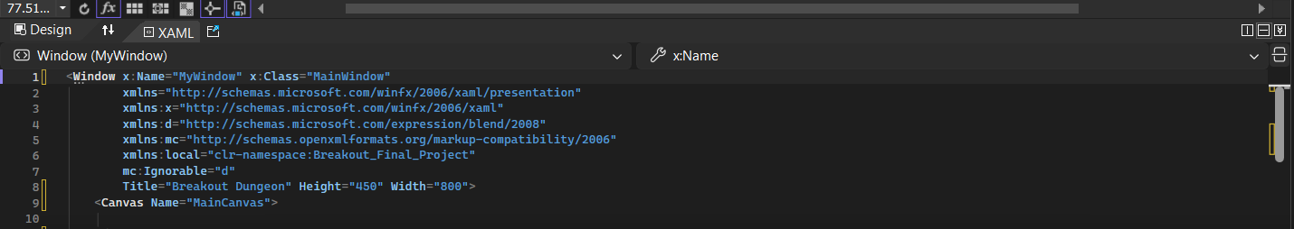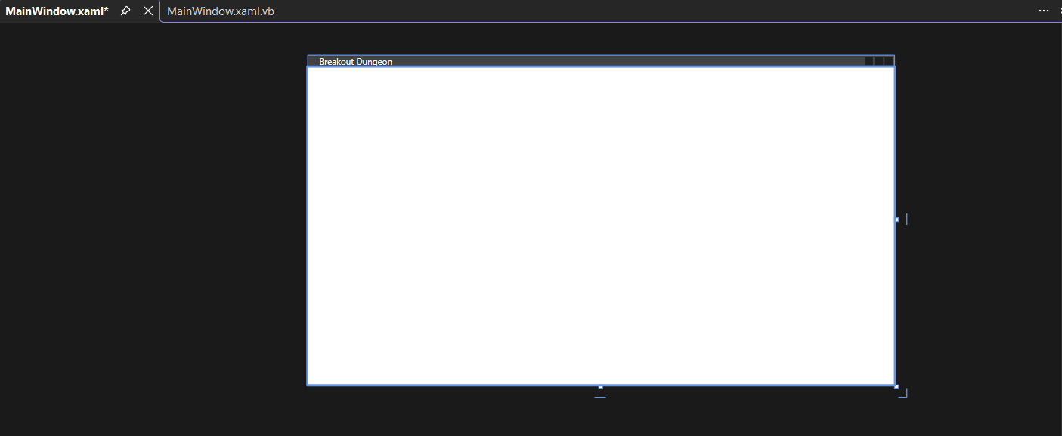
- I started by creating a new WPF project in Visual Studio. Then you set up the main window and added a Canvas, which would act as the game area. After that, you opened the code-behind file and began writing the basic structure for the game, including the paddle, ball, and brick setup. This was the foundation that allowed you to build the rest of the game.
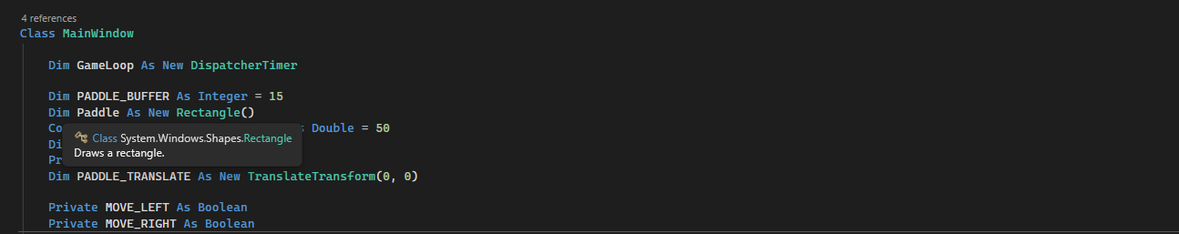
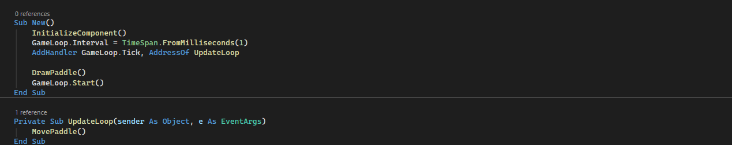
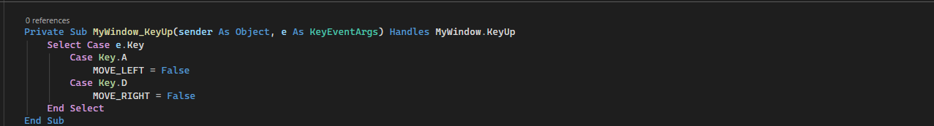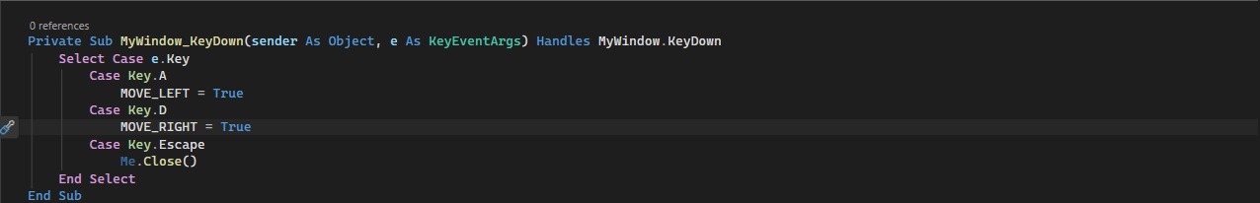
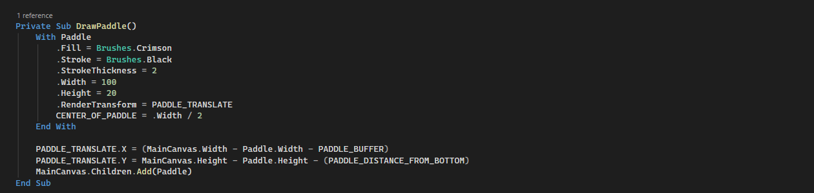
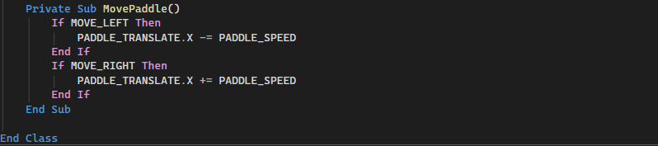
- I started by setting up the main game window and adding the basic variables I needed for the paddle and game loop. Then I created a timer to act as my game loop so the game could update constantly. After that, I made the paddle as a rectangle and added a transform so it could move smoothly across the screen. I wrote the constructor to start the game loop and draw the paddle as soon as the window opened. I added keyboard controls so pressing A or D would move the paddle left or right. I also added key-up controls so the paddle would stop moving when I released the keys. Next, I wrote the DrawPaddle() method to give the paddle its color, size, and position. Finally, I created the MovePaddle() method so the paddle would slide across the screen while the game loop was running.
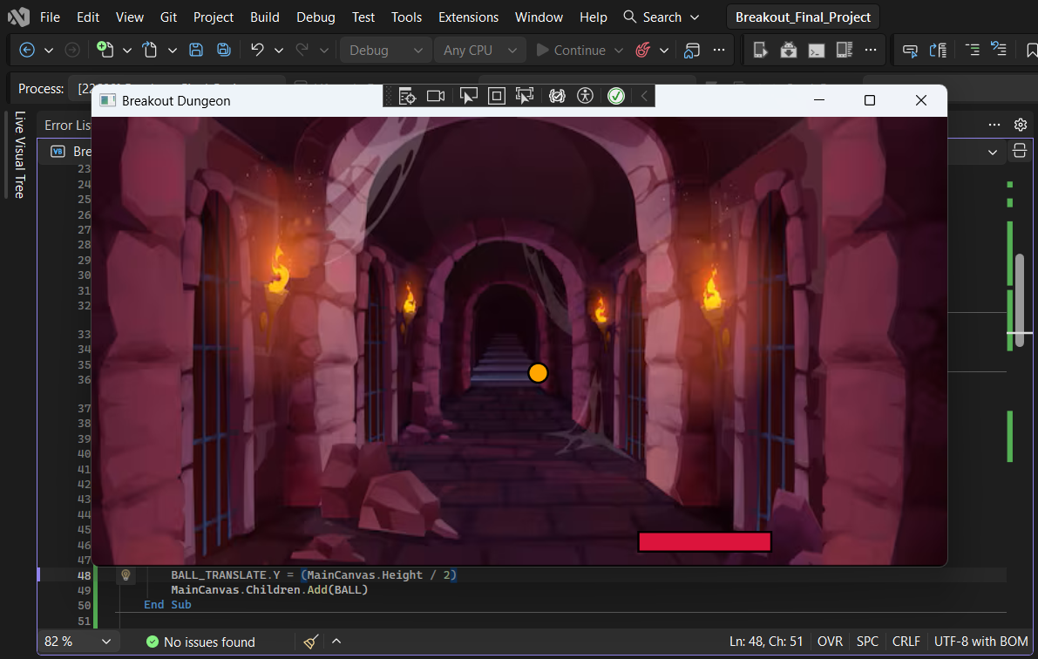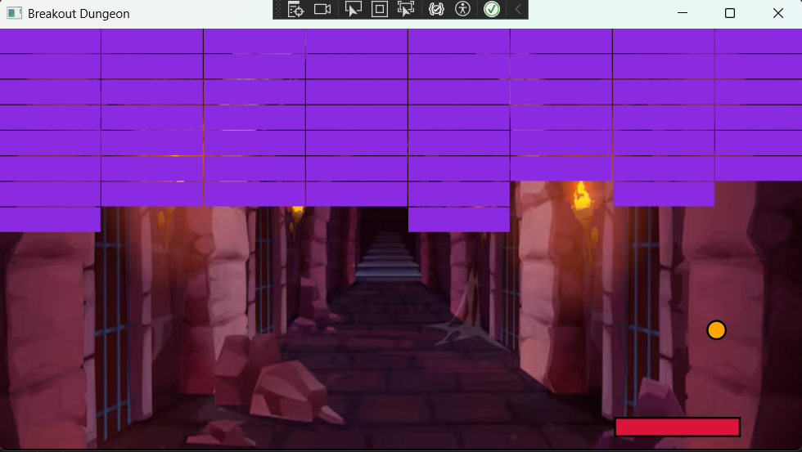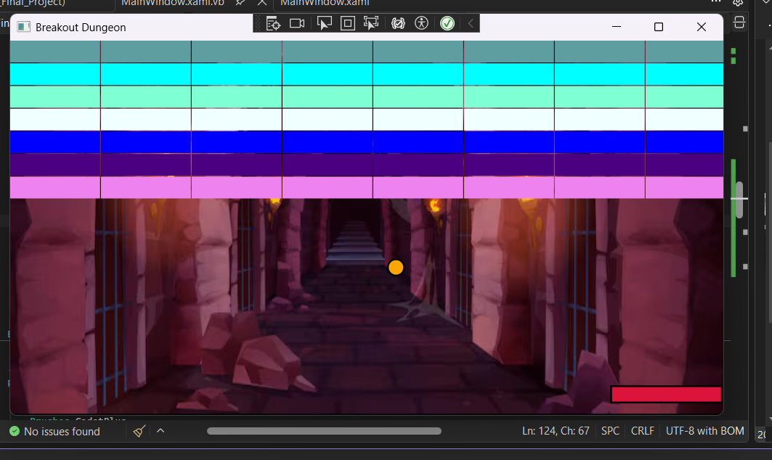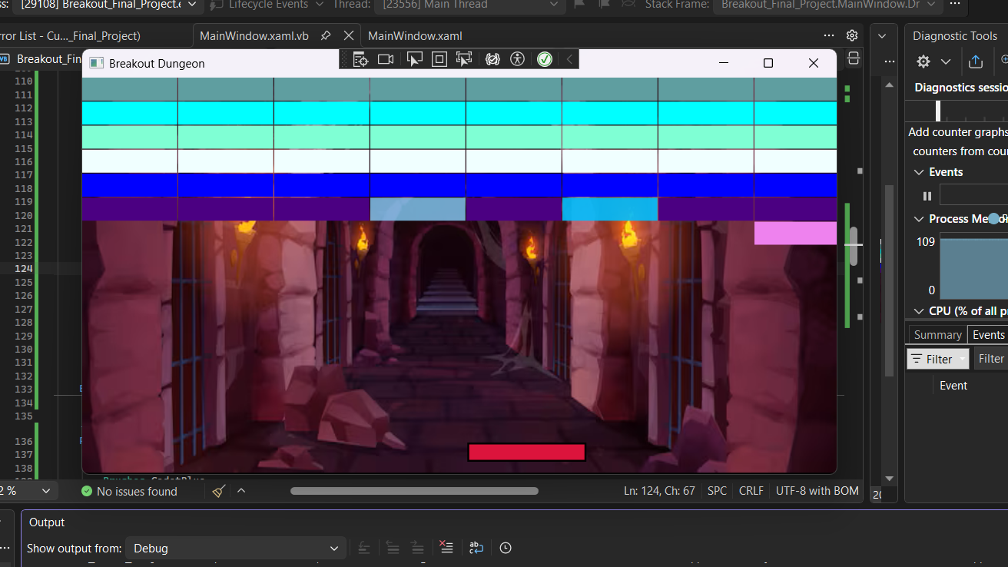
- I started by creating the ball as a small orange ellipse and giving it a translate transform so it could move around the screen. Then I centered the ball on the canvas and added it to the game window so it became visible. After that, I built the brick layout by creating rows and columns of rectangles, each with its own color and position. I added all the bricks to the canvas so they formed the full grid at the top of the game. To handle collisions, I used hit-testing inside the game loop to check when the ball touched a brick. When a collision happened, I removed or updated the brick and reversed the ball’s direction so the gameplay felt like a real Breakout game.

